**LED blinking**

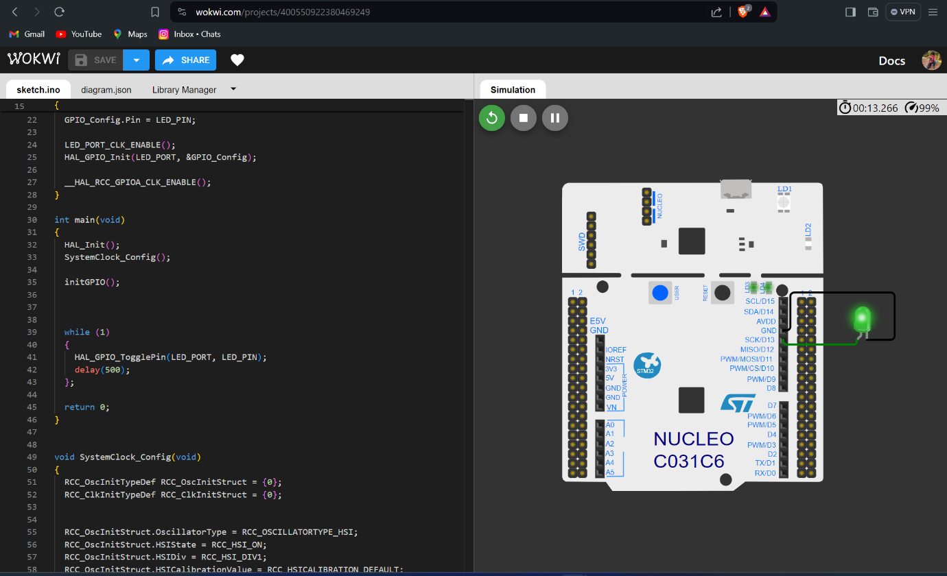

Code

#include <stm32c0xx_hal.h>

#define LED_PORT GPIOA

#define LED_PIN GPIO_PIN_5

#define LED_PORT_CLK_ENABLE __HAL_RCC_GPIOA_CLK_ENABLE

void SystemClock_Config(void);

void initGPIO()

{

GPIO_InitTypeDef GPIO_Config;

GPIO_Config.Mode = GPIO_MODE_OUTPUT_PP;

GPIO_Config.Pull = GPIO_NOPULL;

GPIO_Config.Speed = GPIO_SPEED_FREQ_HIGH;

GPIO_Config.Pin = LED_PIN;

LED_PORT_CLK_ENABLE();

HAL_GPIO_Init(LED_PORT, &GPIO_Config);

__HAL_RCC_GPIOA_CLK_ENABLE();

}

int main(void)

{

HAL_Init();

SystemClock_Config();

initGPIO();

while (1)

{

HAL_GPIO_TogglePin(LED_PORT, LED_PIN);

delay(500);

};

return 0;

}

void SystemClock_Config(void)

{

RCC_OscInitTypeDef RCC_OscInitStruct = {0};

RCC_ClkInitTypeDef RCC_ClkInitStruct = {0};

RCC_OscInitStruct.OscillatorType = RCC_OSCILLATORTYPE_HSI;

RCC_OscInitStruct.HSIState = RCC_HSI_ON;

RCC_OscInitStruct.HSIDiv = RCC_HSI_DIV1;

RCC_OscInitStruct.HSICalibrationValue = RCC_HSICALIBRATION_DEFAULT;

RCC_ClkInitStruct.ClockType = RCC_CLOCKTYPE_HCLK | RCC_CLOCKTYPE_SYSCLK | RCC_CLOCKTYPE_PCLK1;

RCC_ClkInitStruct.SYSCLKSource = RCC_SYSCLKSOURCE_HSI;

RCC_ClkInitStruct.SYSCLKDivider = RCC_SYSCLK_DIV1;

RCC_ClkInitStruct.AHBCLKDivider = RCC_HCLK_DIV1;

RCC_ClkInitStruct.APB1CLKDivider = RCC_APB1_DIV1;

}